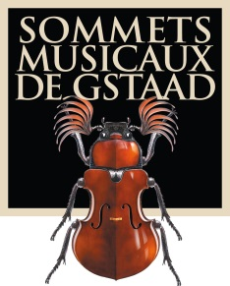

Information for the media

A Tribute to Thierry Scherz
GENEVE, JULY 7, 2014 - Managing director and team of the Sommets Musicaux de Gstaad are deeply saddened to announce the death of Thierry Scherz, artistic director and co-founder of this event, who passed away far too young on July 1, 2014. We shall sorely miss the sense of humour, the kindness and the immense talent of this music lover whose contribution shaped the Festival from the outset and propelled it to the forefront of the international stage. Everyone who is in some way involved with the Sommets Musicaux de Gstaad has lost a friend, a partner, an artist… Ombretta Ravessoud, managing director and co-founder, and the Festival’s loyal team, which has been in place for 15 years, will ensure the continuity and survival of the Festival. The programme for 2015 has already been put together by Thierry Scherz. The concerts will be held from January 30 to February 5 in the churches of Gstaad, Saanen and Rougemont.
The spirit of the Sommets Musicaux will continue as long as Thierry would have wished.
A memorial service for Thierry will be held at the Saanen Church on Thursday, July 10 at 12 noon.

For further information:
Sommets Musicaux de Gstaad: Tél. +41 22 738 66 75 http://sommets-musicaux.ch/
Press office: Christine Urfer, pur pr, christine@pur-pr.com, Mob. +41 78 619 05 00, Tel. +41 21 320 00 10

