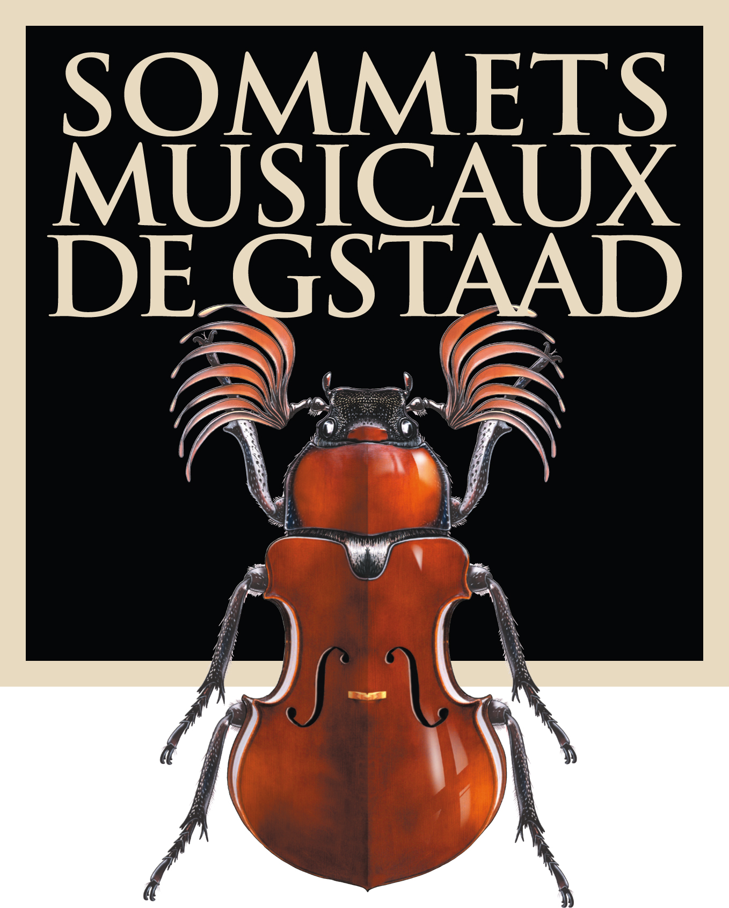

Press Information

15th Sommets Musicaux de Gstaad
30 January to 7 February 2015

The harp as symbol of the unification of heaven and earth

Harpist Emmanuel Ceysson to open the Festival

Three concert cycles in three exceptional venues
Gstaad: discovering young talent
Saanen: the stars of the Festival
Rougemont: the artistic director’s personal favourites

Gstaad, 11 November 2014 – The Sommets Musicaux de Gstaad present the musical programme of their fifteenth edition. From 30 January to 7 February 2015, the harp will be enchanting music-lovers in the churches of Gstaad, Saanen and Rougemont. In the spirit of the Festival’s objectives, unchanged since its inception in 2001, audiences at the Sommets Musicaux de Gstaad will be able to hear outstanding young talent as well as major international virtuosos over the course of nine days.

This 15th year of the festival will present a programme devised by Thierry Scherz, the event’s artistic director and co-founder, who died on 1 July 2014. The management and the whole team behind the Sommets Musicaux de Gstaad will always treasure the humour, generosity and immense talent of this true lover of music who shaped the Festival from its inception, propelling it to the forefront of the international scene. Ombretta Ravessoud, director and co-founder of the festival, says ‘The team behind the Sommets Musicaux de Gstaad have lost a dear friend and colleague as well as an artist, but the spirit of the Sommets Musicaux will live on, just as Thierry would have wanted.’ Ms Ravessoud has promised that the event will continue to flourish, with her team that has supported the Festival over the last 15 years in place.

The harp, as symbol of the unification of heaven and earth
The ancients used to think of harps as mystic gateways or ladders to the kingdom of the world beyond. This explained why Christian angels and messengers from God were often depicted with a lyre or a harp. The harp thus often came to represent communication with the divine and symbolizes the union of heaven and earth.

The Prague Radio Symphony Orchestra, conducted by Ondrey Lenárd with harpist Emmanuel Ceysson and soprano Inva Mula, will have the honour of opening the Festival on 30 January in the church of Saanen. This represents an opportunity to get to know this ensemble, who will be linking works from different styles and repertoires including Schubert, Dvořák and Glière.

Emmanuel Ceysson, mentor to the rising stars
Emmanuel Ceysson, virtuoso ‘enfant terrible’ of the harp, vigorously challenges the clichés associated with his instrument. Fired by a passion to communicate and boundless resources of energy, his playing reveals a glittering instrument whose poetry is every bit the equal of its temperament. His unstinting dedication to his instrument has earned him the distinction of the very highest accolades. When asked why he chose the harp as an instrument, Emmanuel Ceysson replies: ‘When I was six, I fell in love with Mozart’s Flute and Harp Concerto. It was a kind of revelation: this timbre, this resonance, those arpeggios made an impression on me like no other music before.’

Ombretta Ravessoud explains: ‘Thierry Scherz and I often used to discuss Emmanuel’s enthusiasm, his ambition to bring the harp to a wider audience and to bring it centre stage in the classical scene. We never had the slightest doubt that one day he would be the mentor to our rising stars here, and we’re delighted to welcome him in this capacity.’ Let’s not forget that Emmanuel Ceysson knows the Festival well, having been one of the young performers himself in 2005. By recruiting him as a mentor, the Sommets Musicaux de Gstaad hope to turn this example of a young virtuoso harpist to good advantage, seeing that he has become one of his generation’s most talented young musicians. He is sure to be able to communicate his experience, his passion and his talent to the coming generation of young musicians.

Ivan Fedele, composer in residence
The harp will take centre stage every day from 4pm to 5pm in the enchanting chapel of Gstaad, with works by Bach, Mozart, Flagello, Piazzolla, Parish Alvars, Walter-Kühne, Glinka, Prokofiev, Rubinstein, Rachmaninov, Fauré, Debussy, Liszt, Salzedo, Khachaturian, Boldachev, Hindemith, Spohr and Fedele performed by the Festival’s rising stars. In 2015, the new generation of harpists will be represented by the Lithuanian Agne Keblyte, Alexander Boldachev, a Russian based in Zurich, Giulia Ott from Switzerland, Coline Jaget, Agnès Clément and Anaïs Gaudemard from France, Remy van Kesteren from the Netherlands and Sarah Verrue from Belgium.

With the participation of Ivan Fedele as composer in residence, the Sommets Musicaux de Gstaad have secured an outstanding artist of the present day. A composer and pianist, he studied electronic music for 11 years with Angelo Paccagnini in Milan, as well as reading philosophy at the University of Milan. The award of the Prix Gaudeamus in Amsterdam in 1981, which he received for his works Primo Quartetto and Chiari, confirmed his international status. Ivan Fedele is resident in Milan and teaches composition at the Giuseppe Verdi Conservatory, as well as at the Conservatoire régional in Strasbourg. Since 2009 he has been artistic director of the I Pomeriggi Musicali orchestra in Milan. Ombretta Ravessoud says: ‘Ivan Fedele is a distinguished teacher who is always working to devise new formal strategies to enable him to combine various narrative aspects of the Classical and Romantic symphonic model with contemporary innovations in composition and the modern electronic methods of the last 50 years. We can be sure that his presence in Gstaad will be a great boost for our young talented artists.’ Ivan Fedele has been commissioned by the festival to write eight pieces, previously unpublished, entitled Gstaad Variations, to be given their world premiere by the ‘rising stars’ who will be performing in the chapel of Gstaad.

Two prestigious awards
The Prix Pro Scientia et Arte represents an opportunity to recognize one young virtuoso and offer them encouragement by giving them the chance to record a CD with orchestra for the ONYX Classics label. The prize is a recognition of their talent and a potential gateway to an international career.

The new Pro Scientia et Arte CD on ONYX Classics featuring the piano duo Lidija and Sanja Bizjak, winners of the prize in 2014, together with the Stuttgart Philharmonic Orchestra and conductor Radoslaw Szulc, was recorded in September 2014. It will be on sale at the entrance to the chapel in Gstaad.

The Prix André Hoffmann, endowed with 5000 Swiss francs, will be awarded for the best interpretation of a work by Ivan Fedele. André Hoffmann’s support also enables the subsidy of the composer in residence’s work and accommodation.

The stars of the festival
The church of Saanen will thrill to the sound of works by Schubert, Dvořák, Glière, Mozart, Haydn, Chopin, Brahms, Marais, Vivaldi, Purcell, Franck, Fedele, Chopin, Beethoven, Berg, Handel and Wagner.

The Prague Radio Symphony Orchestra, under the baton of Ondrej Lenárd, will celebrate the harp at the opening concert on 30 January in the church of Saanen, alongside Emmanuel Ceysson and Albanian soprano Inva Mula, renowned for singing on the soundtrack of Luc
Besson’s film The Fifth Element. The week’s concerts are sure to provide its loyal audience with a series of thrilling highlights featuring many distinguished artists, including the Philharmonic Chamber Orchestra of Poland on 31 January conducted by Wojciech Rajski with the Austria-based Russian pianist Elisabeth Leonskaja, a regular visitor to the festival, and the Sinfonia Varsovia with the Swiss conductor Michel Tabachnik and the remarkable Croatian pianist Ivo Pogorelich on 6 February, as well as the Vienna Chamber Orchestra conducted by Stefan Vladar with the virtuoso Daniel Lokavitj, 14 years young, on the violin, in the closing concert on 7 February.

The artistic director’s ‘coups de cœur’
The Romanesque church in Rougemont will play host to the ‘coups de cœur’, the personal favourites, of the festival’s former artistic director Thierry Scherz: Russian pianist Arcadi Volodos, who will give a recital containing works by Brahms and Schubert on Sunday 1 February, the Geneva Camerata (GECA), with their talented conductor David Greilsammer and American mezzo-soprano Jennifer Larmore, accompanied by oboists Ramón Ortega Quero and Carlos del Ser on 2 February. A quartet formed specially for the occasion, including violinist Dora Schwarzberg, Italian pianist Giuliano Mazzoccante, violist Nora Romanoff and cellist Romain Garioud, will be delighting music-lovers with works by Franck and Brahms on 3 February. On 4 February, the famous Vienna Piano Trio – consisting of violinist Wolfgang Rednik, cellist Marcus Trefny and pianist Stefan Mendl – will be accompanying the Lucerne-based Regula Mühlemann, one of the most gifted sopranos of her generation. On 5 February, the ensemble ‘Emmanuel Ceysson and Friends’ have been given carte blanche to present a special evening for all lovers of music.

A true winter rendezvous
Over a total of 17 high-quality concerts from 30 January to 7 February 2015, audiences will be inspired by a range of musicians who can make their instruments sing through their talent alone. The Sommets Musicaux de Gstaad, it should be added, are one of the few festivals in Switzerland whose concerts take place exclusively in churches – to the delight of music-lovers who particularly value the unique magic and intimate atmosphere of this event.

The Sommets Musicaux de Gstaad, a true winter rendezvous in the region, will be organizing dinners after several of the concerts, thus creating a rare opportunity for a music-loving audience to meet the artists, thanks to the patronage of a variety of active partners – individuals, business ventures, foundations and associations – including Les Amis des Sommets Musicaux de Gstaad, Madame Vera Michalski-Hoffmann, Madame Aline Foriel-Destezet and Sotheby’s, to name only a few.

Hotel partnerships
The Sommets Musicaux de Gstaad enjoy partnerships with two major hotels:
The Gstaad Palace (www.palace.ch) and the Bernerhof (www.bernerhof-gstaad.ch). Both these hotels offer a set rate to music-lovers wishing to attend the Sommets Musicaux de Gstaad during their stay at the resort.

Programme, tickets and advance sales
www.sommets-musicaux.ch

Tickets will be on sale from 15 December 2014. Bookings can be made at the tourist office in Gstaad or as shown:

- Gstaad tourist office: +41 33 748 81 82 ticketing@gstaad.ch
- Rougemont tourist office: +41 26 925 11 66 info@rougemont.ch
- www.ticketcorner.ch 0900 800 800
- at the venues

Ticket prices: between CHF 25 and CHF 150, depending on the category and the venue
Cost of dinner per head at the Gstaad Palace: CHF 190
Cost of dinner per head at the Café du Cerf in Rougemont or at the Hotel de Rougemont, Restaurant le Roc: CHF 60
Young persons’ rate (‘Jeunesse’, for those aged between 5 and 25): 50% discount
Locals’ rates (‘Indigènes’): 10% discount

A brief look at the Sommets Musicaux de Gstaad
From its inception in 2001, the Sommets Musicaux de Gstaad festival has been hailed as the reference point in winter festivals, an event to delight all aficionados of classical music. Every year young talented musicians, internationally renowned artists and music-lovers from Switzerland and abroad gather in this enchanting snow-capped paradise to enjoy some of the finest works in the classical repertory.

The festival was established by Thierry Scherz, as artistic director, and Ombretta Ravessoud, chief organizer, and since it was founded has been structured in three categories. In the afternoon, the Gstaad Chapel welcomes the pick of promising young artists. In the evening, the churches of Rougemont and Saanen are filled with the sounds of celebrated soloists and internationally reputed orchestras.

Les Amis des Sommets Musicaux de Gstaad
Founded straight after the initial series of concerts by a group of music-lovers and chaired by Denise Elfen, the friends’ association Les Amis des Sommets Musicaux de Gstaad has grown steadily since. It has been supporting the Festival for over twelve years, by financing the concerts in the church at Saanen and in many other ways. This year, the association is pleased and proud to sponsor the evening concert on 6 February.

The complete press kit including press release, biographies of the artists, the full programme of events, HD illustrations of the artists and of the various venues, along with the Sommet Musicaux logo and the accreditation form can be downloaded here: http://sommets-musicaux.ch/presse?language=fr.

For organisational reasons, we would be grateful if you could obtain your accreditation before 1 January 2015.

Media contact:

Switzerland
Christine Urfer, pur pr, christine@pur-pr.com, +41 78 619 05 00, +41 21 320 00 10

France
Valérie Samuel, Opus 64, v.samuel@opus64.com, +33 1 40 26 77 94

