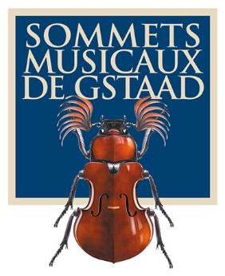
Press release
Sommets Musicaux de Gstaad:
Three young pianists to receive two prestigious awards

Guillaume Bellom and Kevin Jansson
Awarded the Prix Thierry Scherz
Sponsored by the Fondation Pro Scientia et Arte

Rémi Geniet
Winner of the Prix André Hoffmann

GSTAAD, 22 FEBRUARY 2016 – The 16th Sommets Musicaux de Gstaad has awarded the Prix Thierry Scherz, sponsored by the Fondation Pro Scientia et Arte, jointly to 23-year-old French pianist Guillaume Bellom and 15-year-old Irish pianist Kevin Jansson. 23-year-old French pianist Rémi Geniet has been awarded the Prix André Hoffmann.

The three prizewinners gave their concerts in the chapel of Gstaad as part of the ‘Young Talent’ series.

The Prix Thierry Scherz is awarded for the best performance in the ‘Young Talent’ series, offering the winners the opportunity to record their first CD.

This year, the jury, comprising Renaud Capuçon, the festival’s artistic director, Joseph Moog, pianist and series mentor, Thierry Escaich, contemporary composer in residence, and Dominique Fernandez from the Académie française, awarded the Prix Thierry Scherz jointly to Guillaume Bellom and Kevin Jansson. The two pianists will each record their first CD recital in the course of 2016 with Claves Records, who will also promote the recordings.

Rémi Geniet will receive the Prix André Hoffmann, endowed with 5000 Swiss francs, for the best performance of a contemporary work by Thierry Escaich.

An organizational success

The 2016 festival, the first devised and programmed by Renaud Capuçon, took place from 29 January to 6 February and was a great success.

The concerts played to consistently packed halls of enthusiastic music-lovers.

Renaud Capuçon, who was born and raised in the Savoie region of France, expressed his delight at having the opportunity to combine two of his passions in the festival’s theme, ‘Music and the mountains’. The intimacy and magical setting of the churches that double as the Gstaad festival’s concert halls were a particularly charming source of inspiration for Capuçon as he planned the Festival programme.

He is delighted to join the Festival team, who are very proud to welcome their new artistic director to Gstaad.

The new team is very excited to be part of the future of the Sommets Musicaux de Gstaad.

The 17th Sommets Musicaux de Gstaad will take place from 27 January to 4 February 2017

HD illustrations, artist biographies and prizewinners of the 2016 event can be found at :
www.sommets-musicaux.ch/presse

Switzerland
Christine Urfer, pur pr, christine@pur-pr.com, +41 78 619 05 00, +41 21 320 00 10

