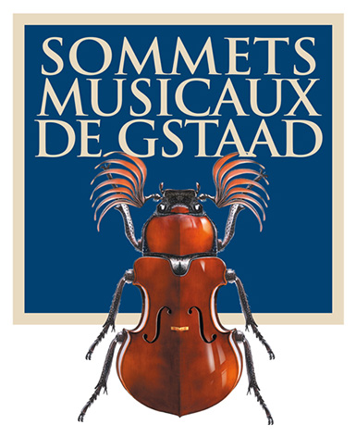
Press release

Sommets Musicaux de Gstaad:
Three young artists to receive two prestigious awards

Caroline Goulding, violin
Awarded the Prix Thierry Scherz
Sponsored by the Fondation Pro Scientia et Arte
and
Les Amis des Sommets Musicaux de Gstaad

David Petrlik, violin and Alexandre Kantorow, piano
Winners of the Prix André Hoffmann

GSTAAD, 10 FEBRUARY 2017 – The 17th Sommets Musicaux de Gstaad has awarded the Prix Thierry Scherz, sponsored by the Fondation Pro Scientia et Arte and by the Friends of the Sommets Musicaux de Gstaad, to 24-year-old American violinist Caroline Goulding. 21-year-old French violinist David Petrlik and pianist Alexandre Kantorow have been awarded the Prix André Hoffmann.

The three prizewinners gave their concerts in the chapel of Gstaad as part of the ‘Young Talent’ series.

The Prix Thierry Scherz is awarded for the best performance in the ‘Young Talent’ series, offering the winners the opportunity to record their first CD.

This year, the jury, comprising Renaud Capuçon, the festival’s artistic director and mentor of the ‘Young Talent’ concert series, Maestro Toshio Hosokawa, contemporary composer in residence, and Patrick Peikert, manager of the Claves Records label, awarded the Prix Thierry Scherz to Caroline Goulding. Caroline will record her first CD with orchestra in the course of 2016 with Claves Records, who will also promote the recording.

David Petrlik and Alexandre Kantorow will receive the Prix André Hoffmann, endowed with 5000 Swiss francs, for the best performance of a contemporary work by Toshio Hosokawa.

An organizational success

The 2017 festival took place from 27 January to 4 February and was a great success. The concerts played to consistently packed halls of enthusiastic music-lovers. The Sommets Musicaux are thrilled at the success of the latest festival season.

The 18th Sommets Musicaux de Gstaad will take place from 26 January to 3 February 2018

HD illustrations, artist biographies and prizewinners of the 2017 event can be found at http://www.sommetsmusicaux.ch/presse/

Switzerland
Christine Urfer, pur pr, christine@pur-pr.com, +41 78 619 05 00, +41 21 320 00 10

