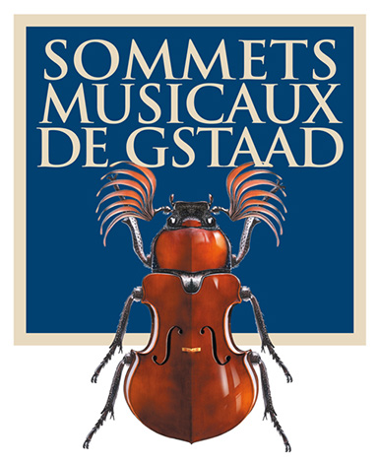
Press release

Two young viola players recognized at the Sommets Musicaux de Gstaad

Timothy Ridout

Winner of the Prix Thierry Scherz
Sponsored by the Fondation Pro Scientia et Arte
and by
Les Amis des Sommets Musicaux de Gstaad

and

Jean Sautereau

Winner of the Prix André Hoffmann

GSTAAD, 5 February 2019 – The 19th Sommets Musicaux de Gstaad has just come to a close, awarding the Prix Thierry Scherz, sponsored by the Fondation Pro Scientia et Arte and by the Friends of the Sommets Musicaux de Gstaad, to 24-year-old English violist Timothy Ridout. The Prix André Hoffmann has been awarded to 23-year-old French violist Jean Sautereau.

Both prizewinners gave their concerts in the Chapel of Gstaad on 27 and 28 January respectively, as part of the ‘Young Talent’ series.

The Prix Thierry Scherz, awarded to Timothy Ridout
The Prix Thierry Scherz is awarded for the best performance in the ‘Young Talent’ series, offering the winner the opportunity to make a CD recording. This year, the jury, under the auspices of Renaud Capuçon, the festival’s artistic director, and comprising Gérard Caussé, mentor of the ‘Young Talent’ concert series, Yann Maresz, composer in residence, and Patrick Peikert, manager of the Claves Records label, unanimously awarded the Prix Thierry Scherz to Timothy Ridout. Timothy, an exciting young viola player, will record a CD with the Bern Symphony Orchestra and the Claves Records label over the course of the second half of 2019. Claves Records will also promote the recording.

The Prix André Hoffmann, awarded to Jean Sautereau
The jury also presented the Prix André Hoffmann to Jean Sautereau. This prize is endowed with 5000 Swiss francs and is awarded for the best performance of Yann Maresz’s work Soliloque (‘Soliloquy’). Maresz is the Festival’s composer in residence.

An organizational success
The 2019 festival – which goes from strength to strength under the stewardship of its artistic director Renaud Capuçon – took place from 25 January to 2 February and was a great hit with audiences. The concerts played to consistently packed halls of enthusiastic music-lovers. The presentation of the children’s story “Le Roi qui n’aimait pas la musique” (The king who didn’t like music), by Karol Beffa, was very warmly received by the local public schools in the region of Saanen, by the Institut Le Rosey and the John F. Kennedy School (Saanen/Gstaad), bringing together over 500 children who had studied the text in French at school beforehand. There is every prospect of a similar project being put on in the future.

The Sommets Musicaux de Gstaad gave its enthusiastic audiences a unique opportunity to discover the viola, which was showcased at the Festival for the first time since its inception. This allowed a new young generation of violists to feature the instrument in the Chapel of Gstaad daily at 4pm. The musicians were mentored by Yann Maresz, the festival’s composer in residence, and Gérard Caussé, one of the world’s foremost viola players, who were able to offer their advice and encouragement to the artists.

The 20th Sommets Musicaux de Gstaad will run from 31 January to 8 February 2020, with the piano in the spotlight as themed instrument.

HD illustrations and biographies of the prizewinners of the 2019 event can be downloaded here: www.sommets-musicaux.ch/presse

Switzerland
Christine Urfer, pur pr, christine@pur-pr.com, +41 78 619 05 00, +41 21 320 00 10

France
Valérie Samuel, Opus 64, v.samuel@opus64.com, +33 140 26 77 94

