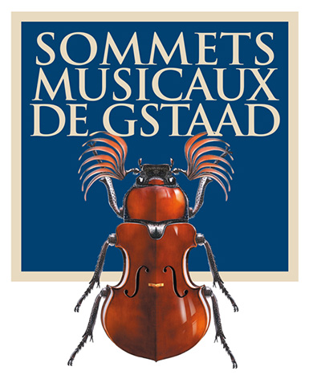

Press release

The 24th Festival of the Sommets Musicaux de Gstaad
from 26 January to 3 February 2024

24th Edition of the Gstaad Sommets Musicaux in 10 Days – Stephen Hough Replaced by Michel Dalberto

Stephen Hough, originally the special guest of the festival, will be replaced by Michel Dalberto due to Hough's illness. This year's festival, themed around the piano, will see French pianist Michel Dalberto stepping in. He will perform at the opening concert with the Bern Symphony Orchestra under the direction of Nicholas Carter on Friday, January 26, 2024, and will also mentor the young pianists competing for the Thierry Scherz and André Hoffmann Prizes.

The festival, directed by Renaud Capuçon, will run from January 26 to February 3, 2024, offering 18 concerts in the churches of Gstaad, Saanen, and Rougemont. It will feature artists such as Martha Argerich, Emmanuel Pahud, Daniel Lozakovich, Bertrand Chamayou, Edgar Moreau, and Bruce Liu, among others, as well as the Hagen Quartet and major Swiss orchestras like the Bern and Lucerne Symphony Orchestras, all while supporting young talents in competition.

Marking the first major classical event of the year, the Gstaad Sommets Musicaux will offer dinners at the Gstaad Palace, promoting interactions between the audience and artists. Notably, cinema legend Marthe Keller will narrate the legend of the beautiful Maguelone in Saanen.

*Michel Dalberto, a prominent figure in classical music, began playing piano at the tender age of three and a half. A student of Vlado Perlemuter at the Paris Conservatory, Dalberto is a prominent figure in the French Piano School of Cortot. Winner of prestigious competitions, including the Clara Haskil Prize in 1975 and the 1st Prize at Leeds in 1978, Dalberto has had a rich career marked by collaborations with major orchestras and artists. His teaching and passion for chamber music set him apart, as do his interest in gastronomy and other passions. Dalberto was a professor at the Paris Conservatory, a position he left in 2022. Since 2023, he has been teaching at the newly established Yehudi Menuhin School that opened in September 2022 in Qingdao, China.

We look forward to welcoming you soon to the enchanting landscape of Gstaad for great moments in music.

Association of the Sommets Musicaux de Gstaad
President: Vera Michalski-Hoffmann
Director: Ombretta Ravessoud
Artistic director: Renaud Capuçon

----------------------------------------------------------------------------------------------------------------------------

Programme, tickets and advance sales
www.sommets-musicaux.ch

Tickets will be on sale at the Gstaad tourist office, at ticketcorner.ch and at the box office in the evening. Ticket sales opened on 11 September 2023. Reservations can be made at:

- Gstaad tourist office: +41 33 748 81 82 ticketing@gstaad.ch

Ticket prices per concert: between CHF 30 and CHF 150 (Swiss francs), depending on the category and the venue
Young persons’ rate (‘Jeunesse’, for those aged between 5 and 25): 50% discount
Locals’ rates (‘Indigènes’): 10% discount
The concert on 28 January at the church of Rougemont at 11am is free of charge
The concert for children on 30 January at the church of Saanen, ‘Die schöne Magelone’ at 10am is free of charge

A brief look at the Sommets Musicaux de Gstaad
From its inception in 2001, the Sommets Musicaux de Gstaad has been hailed as the ultimate reference point in winter festivals, an event to delight all aficionados of classical music. Every year young talented musicians, internationally renowned artists and lovers of music gather in this enchanting snow-capped paradise to perform and enjoy some of the finest works in the classical repertory.

The festival is structured in three categories: three concert cycles spread across three outstanding venues. In the afternoon, the Gstaad Chapel hosts a selection of the most promising young artists. In the evening, the churches of Rougemont and Saanen will delight their audiences with the sounds of celebrated soloists and internationally renowned orchestras.

Les Amis des Sommets Musicaux de Gstaad
Founded following the initial series of concerts, the friends’ association Les Amis des Sommets Musicaux de Gstaad, under the leadership of Véronique de Sénépart, offers invaluable support to the Festival.

The complete press kit including press release, the full programme of events, biographies of the artists and HD images of the artists and of the various venues, along with the Sommets Musicaux logo and the accreditation form, can be downloaded here: www.sommets-musicaux.ch/presse

For organizational reasons, we would be grateful if you could obtain your accreditation by Friday 15 December 2023: www.sommets-musicaux.ch/accreditation-form/accreditation-form-in-french (French version)

Media contact:

Switzerland and abroad
Music Planet, Alexandra Egli, +41 79 293 84 10, alexandra.egli@music-planet.ch

